Laptop Request Catalog Item

Problem Statement:

Employees in the organization need a quick and efficient way to request laptops
for work. The current process is manual and prone to delays, with no dynamic form
behavior to guide users or ensure accurate data collection. To address this, a Service
Catalog item needs to be created, allowing users to easily request a laptop, with
dynamic fields, clear instructions, and additional functionality like resetting the
form if needed. The solution should also ensure all changes are tracked for governance
and deployment.

- Open service now.
- And log in to the service now using your given ID and password
- Once it's over
- Then, open Naan Muthalvan home page in the browser
- Here, log in and move to the guided project

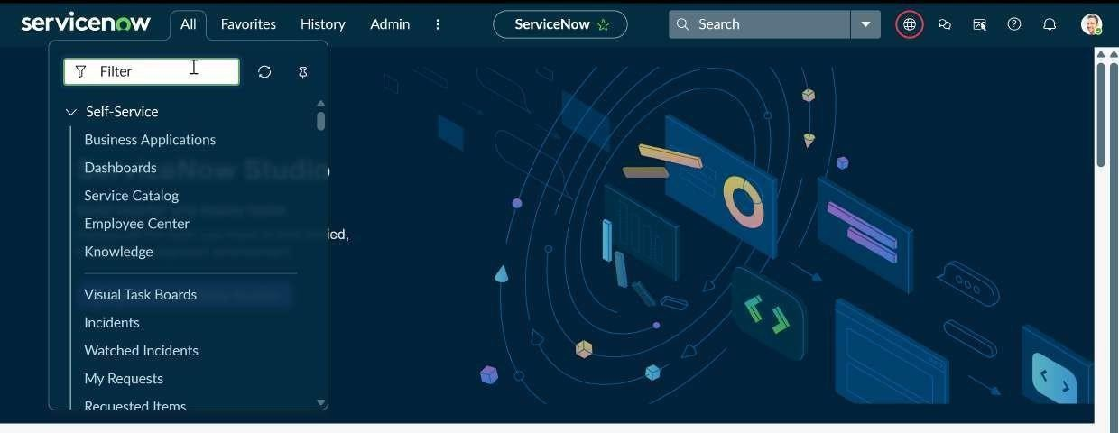

STEP 1: Create Local Update set

- Now in service now, at the top left corner, you can see All
- Click on All >> search for update sets
- Select local update sets under system update sets

- Click on new
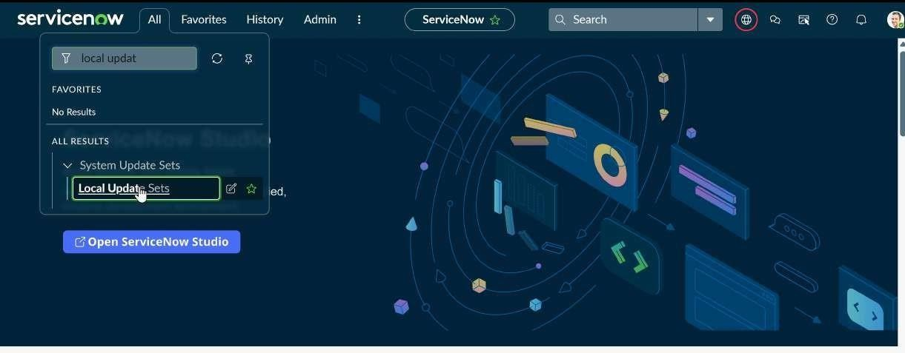
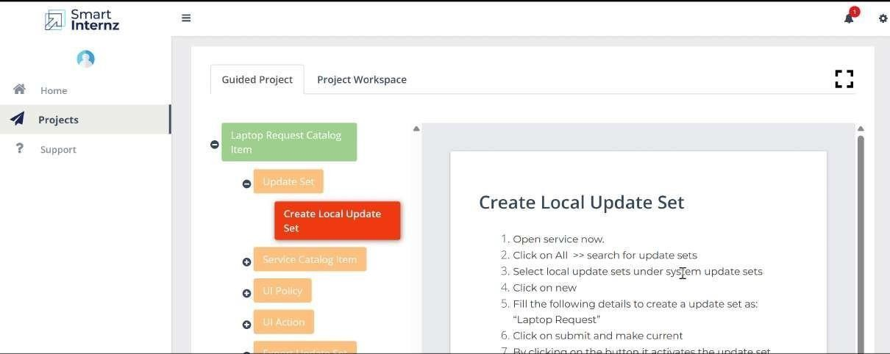
- Fill the following details to create a update set as: “Laptop Request”

- Click on submit to make the current changes.
- By clicking the button, it activates the update set.

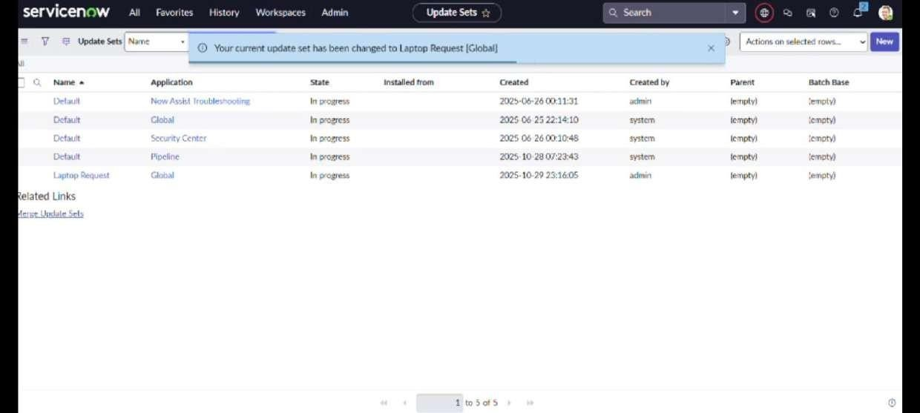

STEP 2: Create Service Catalog Item

- Open service now.
- Click on All >> service catalog
- Select maintain items under catalog definitions
- Click on New.

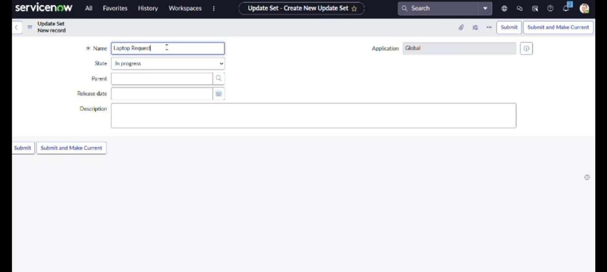

- Fill the following details to create a new catalog item Name: Laptop Request
Catalog: service Catalog Category: Hardware
Short Description: Use this item to request a new laptop
6. Click on ‘SAVE’

STEP 3: Add variables

- After saving the catalog item form scroll down and click on variable(related list)
- Click on new and enter the details as below Variable 1:Laptop Model
Type: Single line text
Name: laptop_model Order:100

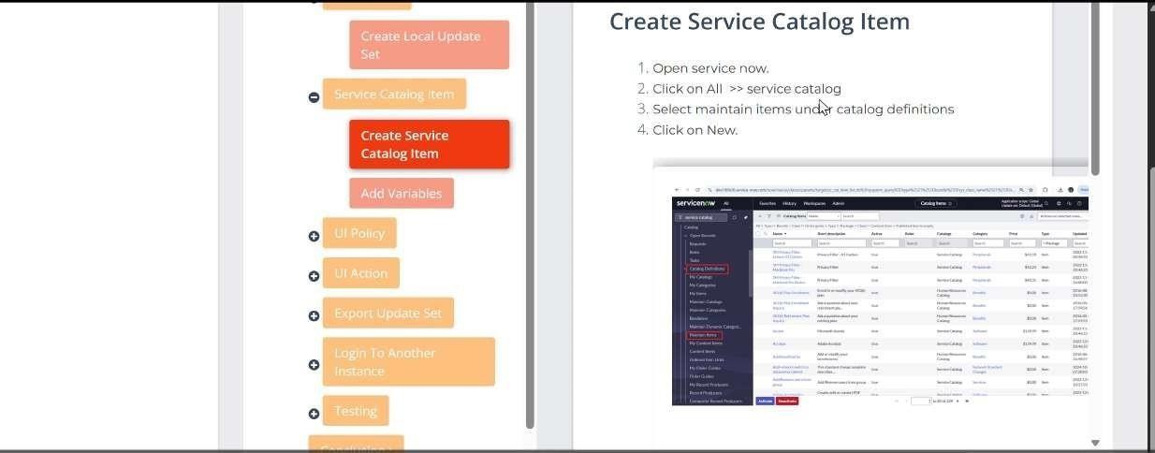

- Click on submit
- Again click on new and add Remaining variables in the above process

Do this same process for 2a. Variable 2:Justification
2b. Variable 3:Additional Accessories 2c. Variable 4: Accessories Details

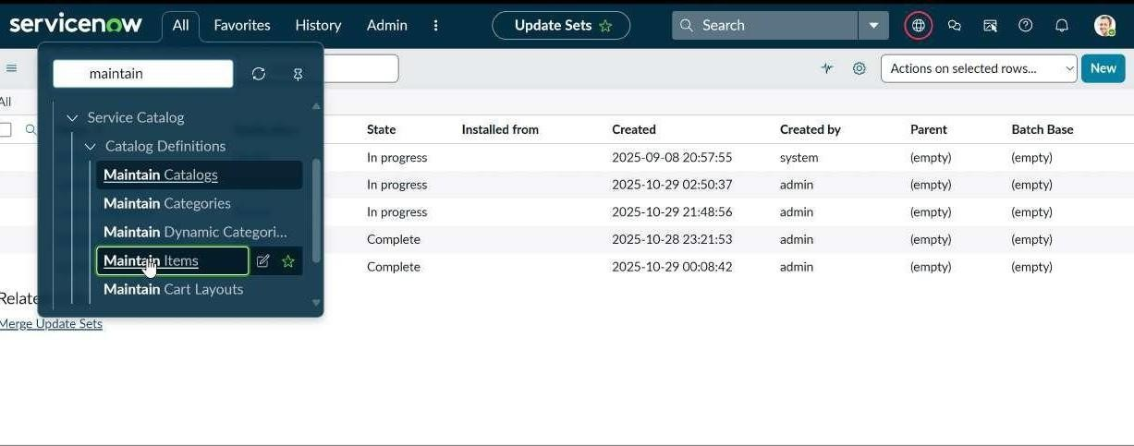

- After adding above variable which are added to newly created catalog item
- Then save the catalog item form

- After adding above variable which are added to newly created catalog item
- Then save the catalog item

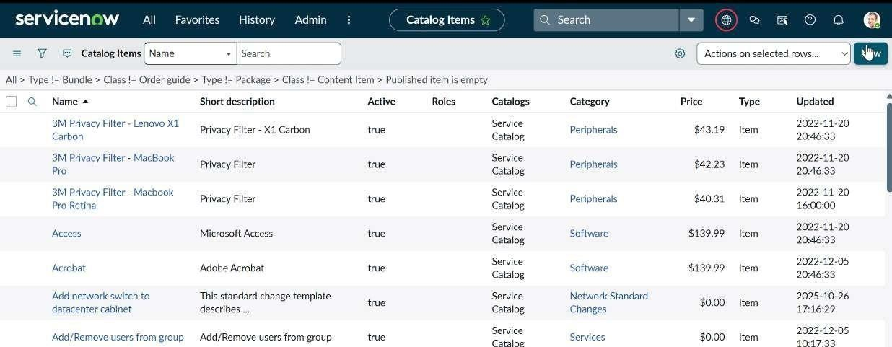

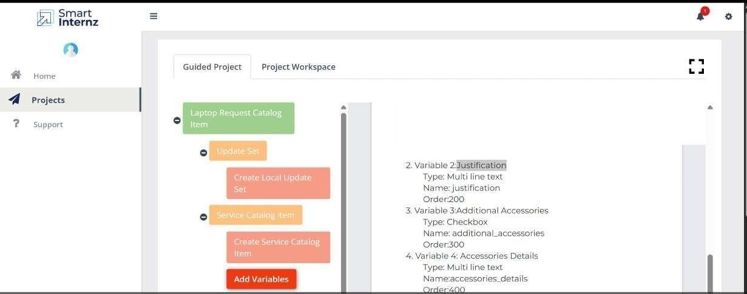

STEP 4: Create Catalog Ui policies

- Click on all>> search for service catalog
- Select maintain item under catalog definition
- Search for ‘laptop request’ which is created before
- Select ‘laptop request’ and scroll down click on “Catalog Ui policies”

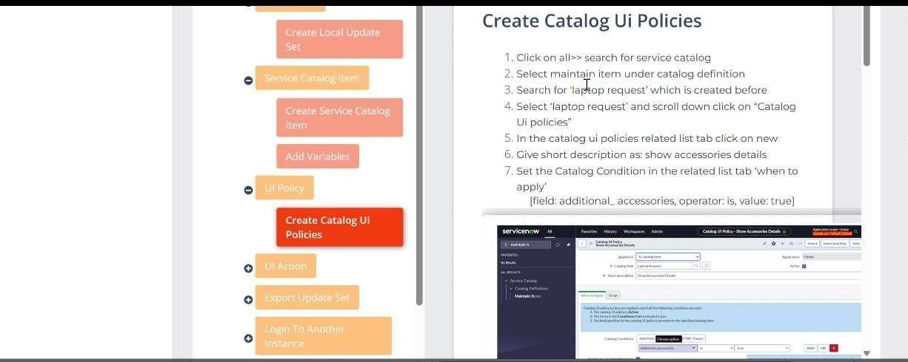

- In the catalog ui policies related list tab click on new

- Give short description as: show accessories details

- Set the Catalog Condition in the related list tab ‘when to apply’ [field: additional_ accessories, operator: is, value: true]

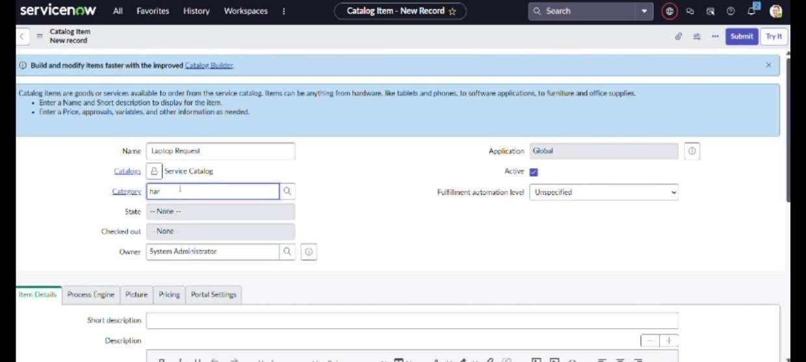

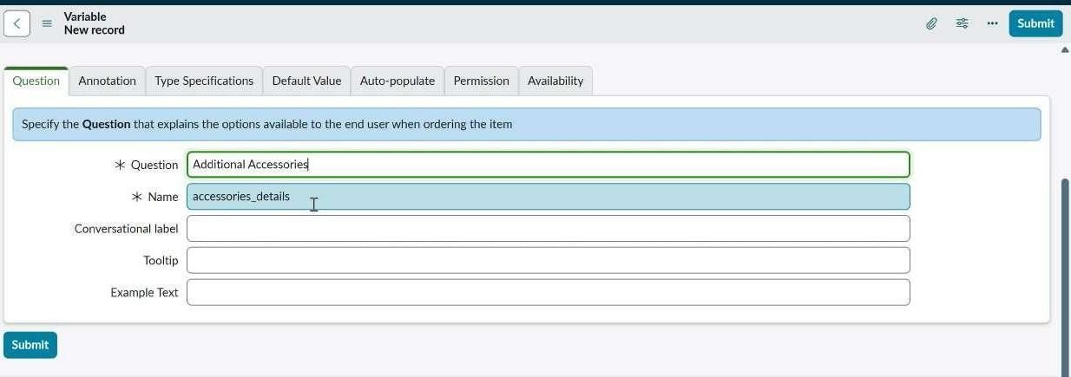

- Click on save.(do not click on submit)
- Scroll down and select ‘catalog ui action’
- Then click on new button
- Select variable name as: accessories_details

  - Order:100
  - Mandatory: True
  - Visible : True

- Click on save and again click save button of the catalog ui policy form

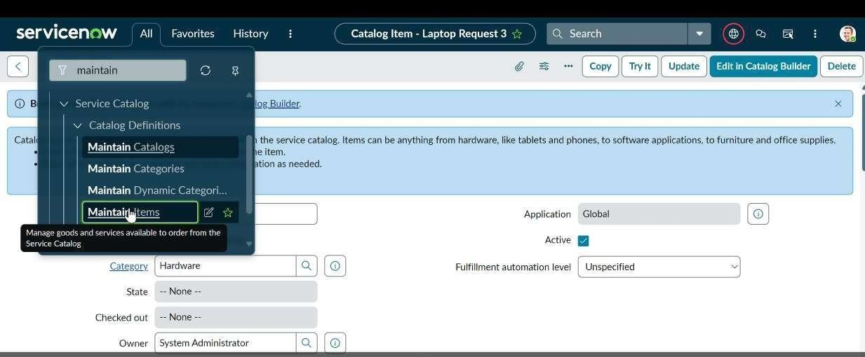

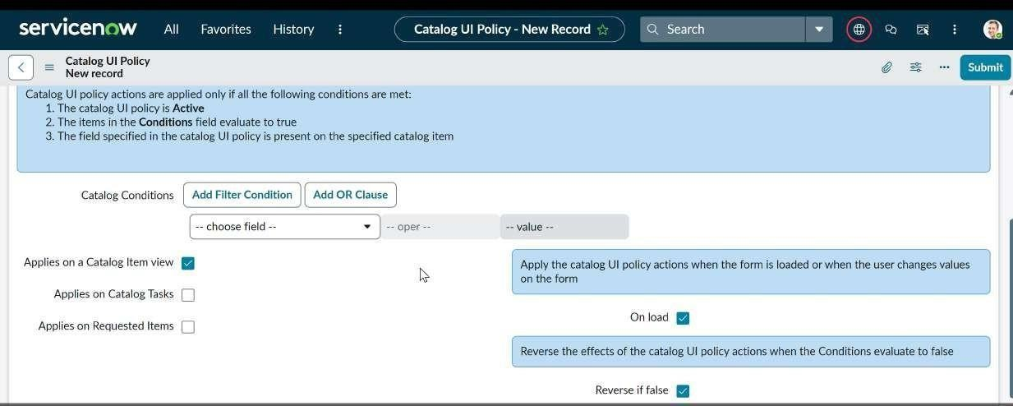

STEP 5: Create ui action

- Open service now.
- Click on All >> search for ui action
- Select ui actions under system definition
- Click on new
- Fill the following details to create ui action Table: shopping cart(sc_cart)
Order:100
Action name: Reset form Client : checked

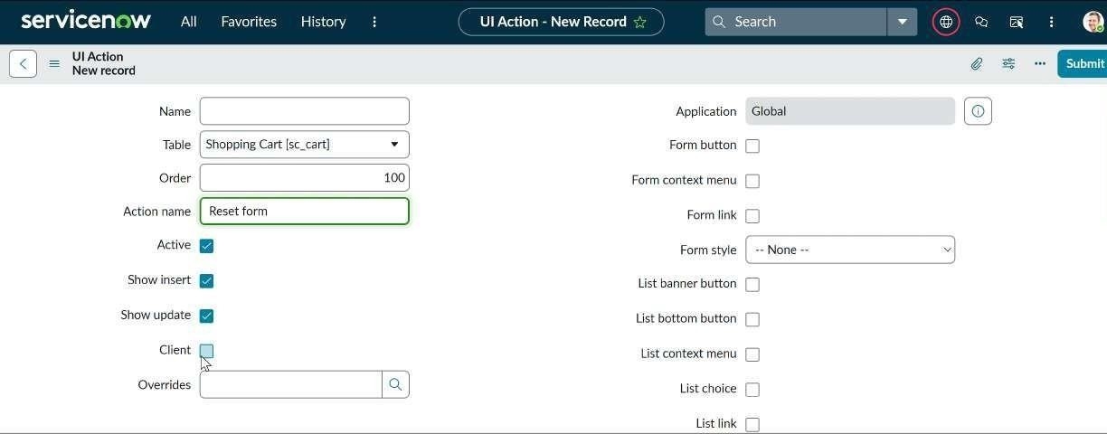

Script:
function resetForm() {
g_form.clearForm(); // Clears all fields in the form alert("The form has been reset.");
}
Click on save
STEP 5:

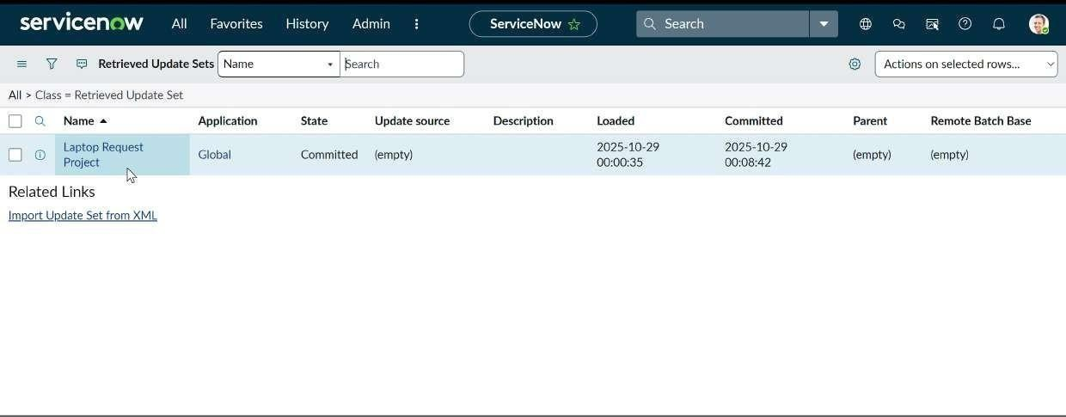
STEP 6: Exporting changes to another instances

- Click on All >> search for update sets
- Select local update set
- Select created update set i.e. ‘Laptop Request Project’
- Set the state to ‘Complete’

- In the related list Update tab, updates are visible which we perform under this update set.
- Click on export to XML ,it download one file

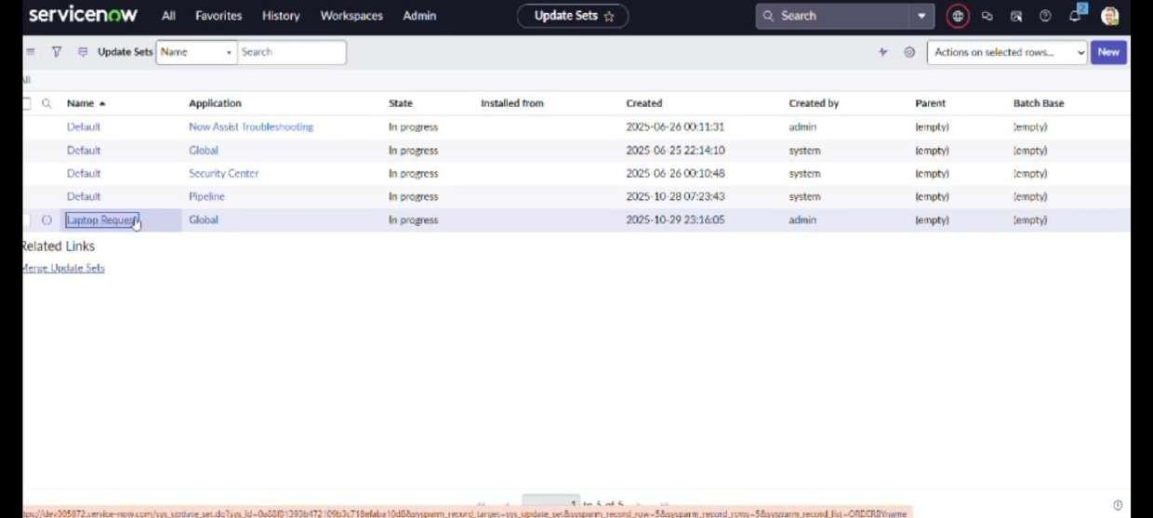

STEP 7:Retrieving the update set

  - Open another instance in incognito window
  - Login with credentials

  - Click on all>> search for update sets
  - Select “Retrieved update set” under system update set

  - It open retrieved update set list and scroll down

  - Click on Import update set from XML

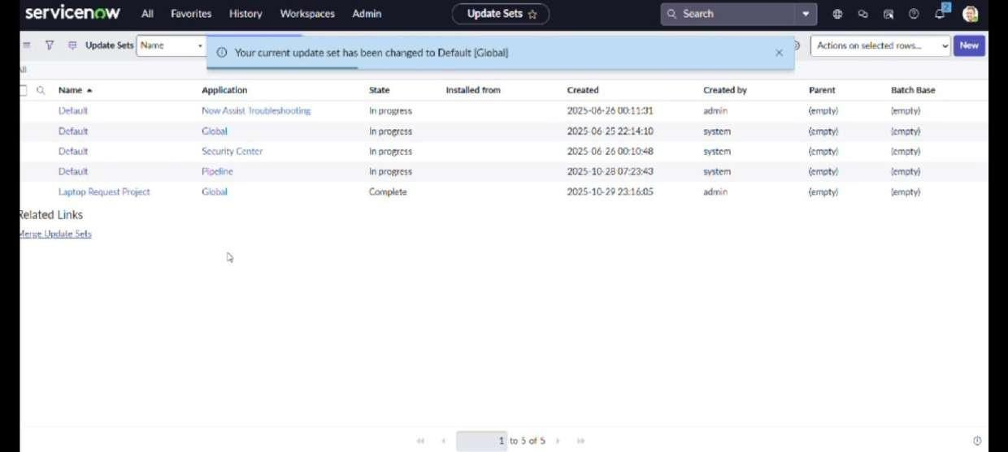

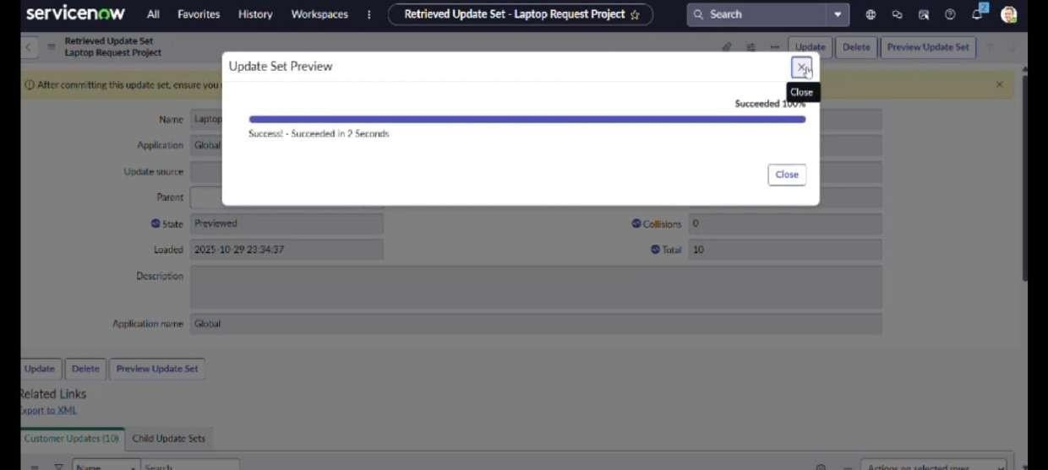

  - Upload the downloaded file in XML file

  - Click on Upload and it gets uploaded.

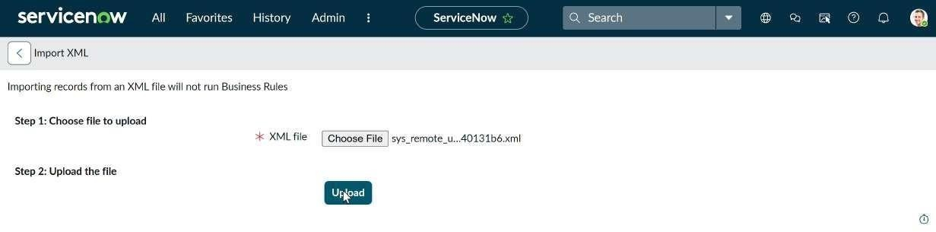

  - Open retrieved update set ‘laptop request project’
  - Click on preview update set
  - And click on commit update set
  - And also see the related tab updates
  - After commiting update set in this instance we get all updates which are done in the previous instance

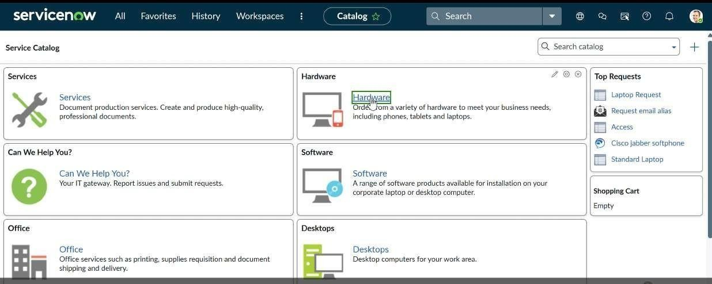

STEP 8: Test Catalog Item

- Search for service catalog in application navigator in target instance
- Select catalog under service catalog
- Select hardware category and search for ‘laptop request’ item

- Select laptop request item and open it

- It shows three variables only

- As per our scenario, when we click on additional accessories checkbox then accessories details fields is visible and that should be mandatory
- Now see the results,it fulfills our requirements

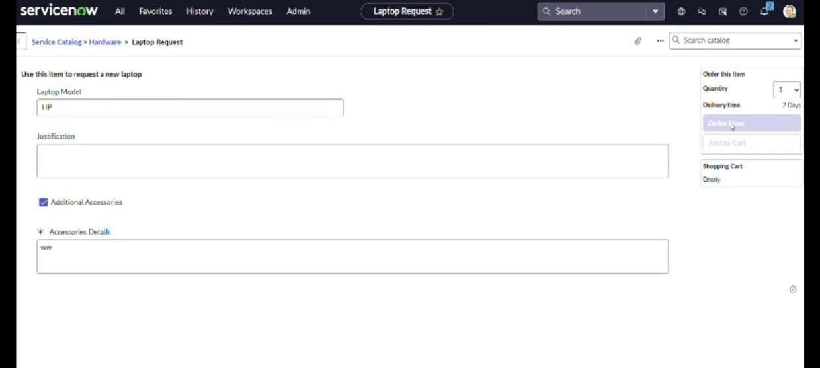

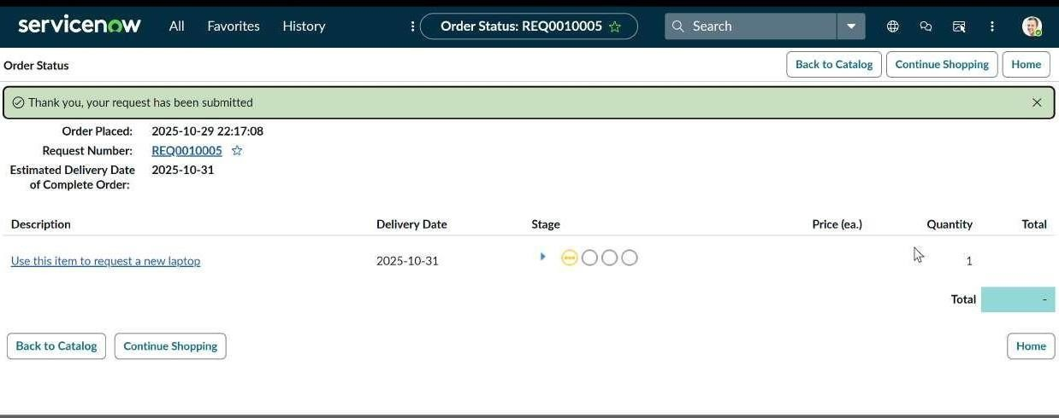

DONE BY,

Team ID : NM2025TMlD05391

Team Leader : Naveen V
Team member : Muthu Selvan A
Team member : Mukesh kannan S
Team member : Muthu Ramanathan R

THANK YOU!

